**DB Designing Task And ER Diagrams**

**Queries used in my database:**

CREATE DATABASE instagram;

CREATE TABLE login(

login_id INT PRIMARY KEY GENERATED ALWAYS AS IDENTITY,

email_id VARCHAR(30) NOT NULL,

password TEXT NOT NULL,

status BOOLEAN NOT NULL,

otp INT NOT NULL DEFAULT 0,

verified BOOLEAN NOT NULL,

status BOOLEAN NOT NULL

);

CREATE TABLE user_tbl(

user_id INT PRIMARY KEY GENERATED ALWAYS AS IDENTITY,

full_name VARCHAR(30) NOT NULL,

user_name VARCHAR(30) NOT NULL,

phone_no BIGINT NOT NULL,

dob DATE NOT NULL

);

CREATE TABLE profile(

profile_id INT PRIMARY KEY GENERATED ALWAYS AS IDENTITY,

profile_pic BYTEA,

bio TEXT,

web_link TEXT,

profile_type VARCHAR(30) NOT NULL

);

CREATE TABLE account(

account_id INT PRIMARY KEY GENERATED ALWAYS AS IDENTITY,

login_id INT REFERENCES login(login_id),

user_id INT REFERENCES user_tbl(user_id),

profile_id INT REFERENCES profile(profile_id)

);

CREATE TABLE account_activity(

activity_id INT PRIMARY KEY GENERATED ALWAYS AS IDENTITY,

account_id INT REFERENCES account(account_id),

device VARCHAR(30) NOT NULL,

latitude NUMERIC NOT NULL,

longitude NUMERIC NOT NULL,

start_time TIMESTAMP NOT NULL,

end_time TIMESTAMP NOT NULL,

ip_address INET NOT NULL,

);

CREATE TABLE post(

post_id INT PRIMARY KEY GENERATED ALWAYS AS IDENTITY,

user_id INT REFERENCES user_tbl(user_id),

post_content BYTEA NOT NULL,

post_caption TEXT NOT NULL,

post_time TIMESTAMP NOT NULL,

like_count SERIAL NOT NULL,

share_count SERIAL NOT NULL,

comment_count SERIAL NOT NULL,

comment_control BOOLEAN NOT NULL

);

CREATE TABLE comment_tbl(

comment_id INT PRIMARY KEY GENERATED ALWAYS AS IDENTITY,

user_id INT REFERENCES user_tbl(user_id),

to_id INT NOT NULL,

post_id INT REFERENCES post(post_id),

comment_content TEXT NOT NULL,

comment_time TIMESTAMP NOT NULL,

like_count SERIAL NOT NULL

);

CREATE TABLE follow(

follow_id INT PRIMARY KEY GENERATED ALWAYS AS IDENTITY,

user_id INT REFERENCES user_tbl(user_id),

following_id INT NOT NULL

);

CREATE TABLE story(

story_id INT PRIMARY KEY GENERATED ALWAYS AS IDENTITY,

user_id INT REFERENCES user_tbl(user_id),

story_content BYTEA NOT NULL,

story_time TIMESTAMP NOT NULL,

story_type BOOLEAN NOT NULL,

view_count SERIAL NOT NULL,

like_count SERIAL NOT NULL

);

CREATE TABLE close_friend(

close_friend_id INT PRIMARY KEY GENERATED ALWAYS AS IDENTITY,

user_id INT REFERENCES user_tbl(user_id),

friend_id INT NOT NULL

);

CREATE TABLE message_tbl(

message_id INT PRIMARY KEY GENERATED ALWAYS AS IDENTITY,

user_id INT REFERENCES user_tbl(user_id),

to_id INT NOT NULL,

message_content BYTEA NOT NULL,

content_type VARCHAR(30) NOT NULL,

message_time TIMESTAMP NOT NULL,

status BOOLEAN NOT NULL

);

CREATE TABLE call_log(

call_id INT PRIMARY KEY GENERATED ALWAYS AS IDENTITY,

user_id INT REFERENCES user_tbl(user_id),

to_id INT NOT NULL,

start_time TIMESTAMP NOT NULL,

end_time TIMESTAMP NOT NULL,

call_type BOOLEAN NOT NULL,

status VARCHAR(15) NOT NULL

);

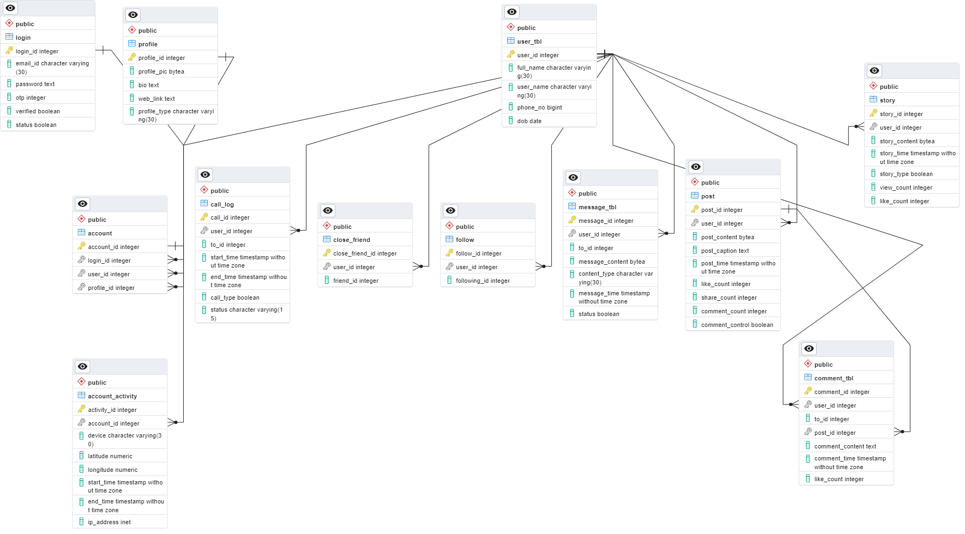**ER Diagram of my Database:**